Question 1
In a table, you should always store a patient's age rather than their actual birthdate.
True
False
Question 2
It is very much preferred that every table has a primary key.
True
False
Question 3
When designing table columns, its always important to choose a data type and size that is relevant to the data that will be stored in this column.
True
False
Question 4
Reports can contain patient centric data, or data that has been aggregated by cohort / condition / location.
True
False
Question 5
Reports can be fundamentally useful to demonstrate the success of a given healthcare initiative.
True
False
Question 6
Reports are only of value for healthcare workers at primary care or hospital settings.
True
False

Question 7
When creating forms for data collection, it is important to offer as many free-text field options as possible so that clinicians can type in long descriptive details by hand...
True
False

Question 8
Health data has a wide range of secondary uses outside of delivering primary care.
True
False

Question 9
Which of the following would be the most suitable for use as a primary key when storing a list of patients in a table?
(For this question, ignore security considerations, and focus only on uniqueness/relevance)
Patient address
Patient phone number

Patient SSN
patient's first name

Question 10
You're storing a list of books in a table using the book's ISBN number as a primary key. One day, you find out that you've entered the wrong ISBN number for one of your books. So you go to you table, and update that book's record with the right ISBN number. Doing so is fine because the book now has the right ISBN assigned...
True
False

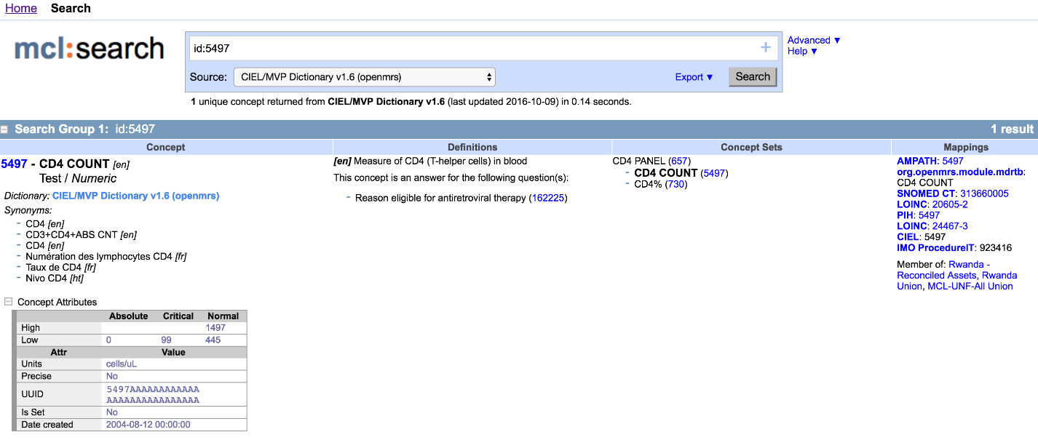
The next few questions are based on the following concept from the maternal concept lab website.
Imagine that you have been asked to create an OpenMRS concept to represent this.
Question 11
Which OpenMRS concept data type would you use?
Question 12
What is the most suitable OpenMRS unit of measurement?
Question 13
List one french synonym and one english synonym for this concept?
Question 14
List the critical low value for this concept?
Question 15
List the LOINC mapping to this concept?
Question 16
This concept can be used as an answer to the concept identified by which id?
313660005
162225

730
923416

Question 17
It has been proposed to use this concept to report the percentage of CD4 lymphocytes. Is this a good idea?
True
False
Question 18
"Any change to the database must be “all or nothing”. Any failed transaction on the database should result in rollback to the previous state."
This is an example of,
Consistency
Atomicity

Isolation
Durability

Question 19
The value of a primary key should be changed frequently.
True
False
Question 20
Remember the classwork assignment where you were asked to create a patient on the OpenMRS platform. (Feel free to re-visit the OpenMRS patient dashboard if necessary).
What patient gender options did OpenMRS provide in the create patient dashboard?
Freetext input for gender entry
Male and female genders only

Male, female, unknown and other genders
A full list of 56 different genders

